**Tailwind CSS Project – Travel Booking Website  
Work Planner 14-day target for delivery  
  
Day 1**

Sample sites for reference: https://www.kayak.co.in/  
 https://www.momondo.in/  
 https://onlineksrtcswift.com/  
 https://www.traveltorq-online.com/  
  
**Meeting Day 1**: Getting to know team members and rough discussion on various travel website designs. Further next day we come up with individual website ideas by referring different travel websites.

Next Meet Agenda: 1. Fix the Website Design template.  
 2. Plan the number of Webpages required.

3. Decide the Name of Website and logo idea.

**Day 2**

Website Design will be based on: https://www.kayak.co.in/  
 https://themewagon.github.io/ecoland/index.html#  
 https://www.expedia.com/

Webpages Requirements:   
  
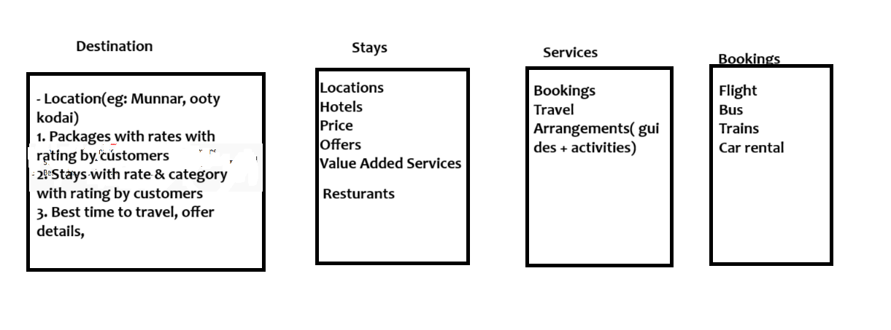  
  
Website Name Suggestions: -

* sanchari
* explorer
* tourist family movie
* Anandham movie
* dream quest
* Swapna sanchari
* vinodhayatra
* paradise
* Passenger
* expedition voyage
* wanderer

Website Color scheme suggestion:

   
  
**Next Meet Agenda**: 1. Finalize the Webpages.  
 2. Finalize the Website Name, Logo, Color Scheme.

**Day 3**

Website Name decided: Vinodhayatra   
  
Color Scheme: Can decide from <https://colorhunt.co/> , suggestions we can finalize in next meeting.

Webpages:   
  
 Will discuss with Sir and finalize, by tomoro.

**Next Meeting Agenda:** 1. Finalize Color scheme and Fonts.

2. Finalize Webpages.

**Points to be confirmed with Sir:** 1. Webpages to be included.  
 2. Website name idea in Malayalam

**Day 4**

- Webpages mock pages to be designed in Figma first then after discussion we proceed for coding.

Figma page designing is allotted as follows:  
  
  
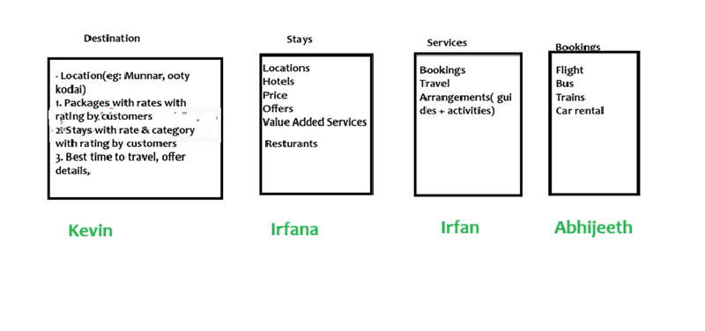

* We all will be designing the above pages in Figma, then have a meeting by 7th June to finalize the same. Everyone can use their own creativity and design ideas including colors fonts etc.
* This is to ensure we have a proper design plan ready before starting the coding.  
  Please try max to include all the components mentioned for the respective pages.
* After completing all the 4 pages we can finalize the ideas for home page.

**Next Meeting Agendas:** 1. Finalize the above pages.

2. Produce ideas for home page.

3. Coding roadmap.

**Day 7**

* Webpages finalized and development work allocated for individuals as below.

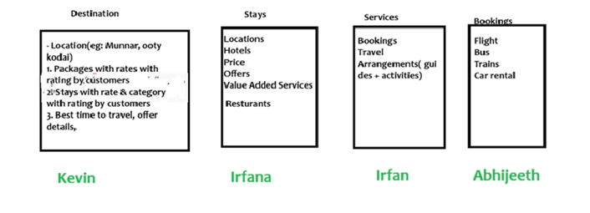

* Will keep updated about the development progress in upcoming meeting.
* Will finalize the contents for Home page after developing the other pages.

**Next Meeting Agendas:** 1. Development review.

2. Logo finalize

**Day 9**

* Please complete the assigned Webpages and mention any challenges in Group.



* Please give suggestion for the logo Kevin has shared in Group need to finalize the same.

**Next Meeting Agendas:** 1. Development review.

2. Logo finalize